03.05.2020



**MIDDLE EAST TECHNICAL UNIVERSITY**

DEPARTMENT OF ELECTRICAL AND ELECTRONICS ENGINEERING

**EE 568** Project #3

***1 MW Wind Turbine Generator Design and Analysis***

GÖKHAN ÇAKAL – **2332120**

# Introduction

In this project, basic terminologies in machine design is studied such as electrical loading, magnetic loading or material selection. The project gives overall good understanding of the machine design steps. In the first part of the project, magnetic loading is found with the cylindrical stator assumption. Then, in the second part, the electrical loading and machine geometry is defined. Using electrical loading and magnetic loading, the average tangential stress is calculated and torque of the machine is found. In the last part, the machine is optimized to achieve maximum torque density. The trade-offs between machine geometrical parameters and torque is investigated. Also, for the same outer diameter and volume, Ferrite magnets are used and optimization study is presented to increase the torque density of the Ferrite machine. The comparative study showed us that Neodymium design has 44% more volumetric torque density and it is more favourable.

# Part I: Literature Review

Nowadays, researchers are focusing on new machine topologies for renewable energy applications such as wind energy. As the regulations gets tighter, the high efficient and high dynamic machines are getting more attention. In that context, axial flux machines are becoming more popular due to their high torque density.

In the wind turbine generator market and literature, there are several solutions or topologies presented according to different aspects. Direct-drive wind turbine generators have low rotational speed, high torque, and large diameter, which pose remarkable design and manufacturing challenges [1]. Direct-drive synchronous generators can be permanent magnet excited or electrically excited [2]. Permanent magnet excitation has the advantage of improved efficiency and lightweight design at the expense of increased material cost. Radial flux iron-cored generators, which are commonly used in direct-drive wind turbines, are studied in [3]. They suffer from high attraction forces between rotor and stator due to Maxwell stresses, which increase the structural mass of the generator. There are also non-conventional generators such as claw-pole or transverse-flux machines, but they operate at low power factors [4]. Superconducting direct-drive generators are also studied, and they promise high torque densities. However, they are not mature enough for commercialization.

The selected topology in this project, axial flux topology, is heavily studied for wind turbine applications. For example, in [5], 5 kW and 200 rpm permanent magnet axial flux generator is presented and tested for wind energy applications. In [6], 30 kW ironless axial flux generator is optimized. Also, various pole and coil numbers are studies for the design. Additionally, axial flux generator topology is studied in superconducting wind turbine generators. For example, in [7], the authors presented an axial flux homopolar generator topology with 6 MW and 12 rpm ratings. However, the superconducting generators are not mature enough for commercialization.

# Part II: Analytical Calculation and Sizing

After quick literature review, we can design analyse the proposed generator. We will start with definition of magnetic loading and electrical loading. Then,

First, let’s introduce the topology. The proposed generator is axial flux, double sided, air cored machine with permanent magnet excitation. The stator is sandwiched between two rotor cores. Compared to conventional stranded wired stators, the proposed generator employs flat winding technology, where the stator wires are manufactured from copper sheet by cutting using laser cut or water jet. The simplified presentation of the generator can be seen in the Figure 1.

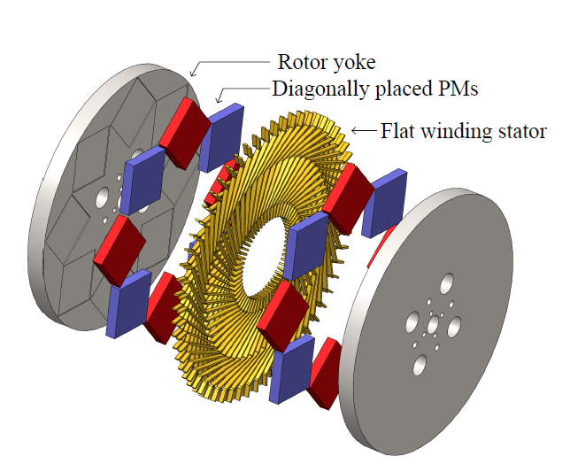

Figure 1: Simplified representation of the proposed generator

The overall specifications of the proposed generator is given in Table 1. The proposed generator employs 46 NdFeB magnets. It’s rated speed is 20 rpm. Since there is no gearbox in the system, the rotational speed is low and torque is high.

Table 1: Overall parameters of the generator

|  |  |
| --- | --- |
| **Parameter** | **Value** |
| Rated power | 1 MW |
| Rated speed | 20 rpm |
| Line voltage | 680 V |
| Rated current | 840 A |
| Pole number | 46 |

## Magnetic loading

First, magnetic loading of the generator will be calculated. To achieve this, the rotor and stator cores are assumed to be infinitely permeable. In the design, N35M grade NdFeB magnets with remanence flux density of 1.212 T are used. Also, in the analysis, it is assumed that there is no leakage and fringing flux in the system, that is, air gap flux density has square shaped magnetic field. The magnetic model of the design is shown in Figure 2 under one pole pair.

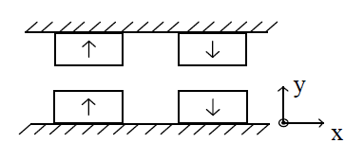

Figure 2: Pole pair representation of the design for magnetic loading calculation

The magnetic equivalent circuit of a magnet can be shown as in Figure 3. It is represented with a voltage source and series added resistance.

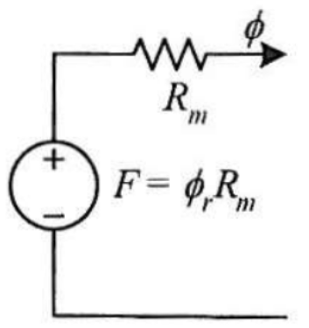

Figure 3: Electrical modelling of a magnet

$$R_{m}=\frac{l_{m}}{μ_{0}μ_{r}A_{m}}$$

$$ϕ_{r}=B_{r}A_{m}$$

Then, the electrical equivalent of a pole pair can be found easily. Air gap is also modelled as a series added resistance. In this analysis, the cores are assumed to be infinitely permeable, where there is no MMF drop. Then, the electrical circuit model of the machine under one pole can be seen as in Figure 4.



Figure 4: Electrical equivalent of the machine under one pole pair

The analytical calculation of air gap flux density starts with derivation of air gap flux. In the analysis, it is assumed that there is no fringing and leakage flux and air gap flux density has square shape. Then, air gap flux can be derived using electrical equivalent circuit as follows:

$$ϕ_{m}=ϕ_{g}=\frac{4ϕ_{r}R_{m}}{4R_{m}+2R_{g}}=\frac{{2ϕ}_{r}R_{m}}{{2R}_{m}+R_{g}}$$

$$ϕ_{r}=B_{r}A_{m}$$

$$R_{m}=\frac{l_{m}}{μ_{0}μ_{r}A_{m}}$$

$$R_{g}=\frac{l_{g}}{μ_{0}A_{g}}$$

$$A_{m}=A_{g}$$

$l_{m}=36.5 mm$ and $l_{g}=47.3 mm$

$$ϕ_{g}=A_{m}*1.212*\frac{2*\frac{36.5}{1.05}}{2*\frac{36.5}{1.05}+47.3}=0.712 A_{m}$$

$$B_{g}=\frac{ϕ_{g}}{A_{g}}=\frac{ϕ_{g}}{A_{m}}=0.712 T$$

It is found that air gap peak flux density is 0.712 T, analytically. Magnetic loading is defined as average of fundamental component of the air gap flux density. It is assumed in our analysis that air gap flux density has square shaped waveform. Its peak of fundamental component can be found as

$$B_{p1}=B_{square}\frac{4}{π}\sin\left(\frac{θ_{m}}{2}\right)$$

$$B_{p1}=0.712\frac{4}{π}\sin\left(90*0.8\right)=0.873 T$$

$$B_{avg}=B_{p1}*\frac{2}{π}=0.873*\frac{2}{π}=0.556 T$$

The magnetic loading of the generator is found to be 0.556 T. The typical magnetic loading for permanent magnet machines is between 0.55-0.8 T. Considering that the design is air cored, the obtained magnetic loading value makes sense.

## Electrical loading

In the design, novel flat wires are used instead of conventional stranded wires. It has current density of 3.8 A/mm2. The cross sectional area of the flat wire is 3x18.6 mm2. Therefore, current of a flat wire can be calculated as follows

$$J=3.8 A/mm^{2}$$

$$A_{wire}=3x18.6 mm^{2}=55.8 mm^{2}$$

$$I_{wire}=JxA_{wire}=212 A$$

In the design, two stages exist. In each stage, there are two parallel turns. Therefore, for 1 MW machine, the phase current is 848 A and it has line voltage of 680 V. The electrical loading of the generator can be calculated as follows

$$A=\frac{N_{fw }I_{wire}}{2πr_{mean}}=\frac{2898*212}{2*π*2.23}=43.8\frac{kA}{m}$$

where $N_{fw}$ and $r_{mean}$ are number of flat wires per stage and mean radius, respectively. For PMSM, as a rule of thumb, the electrical loading should be between 35-65 kA/m. Our calculation is coherent with this values.

## Average tangential stress and torque

The average tangential stress is calculated as follows

$$σ=\frac{AB_{p1}\cos{θ}}{\sqrt{2}}=\frac{43.8*0.873T*1}{\sqrt{2}}=27 kPa$$

The torque of the machine can be calculated by tangential stress. However, we should first find the air gap area

$$A_{airgap}=π\left(r_{out}^{2}-r_{in}^{2}\right)=4.28 m^{2}$$

where $r_{out}$ and $r_{in}$ are outer and inner radius of the generator, respectively. Then, the torque can be expressed as

$$T_{stage}=σA_{airgap}r_{mean}=27kPa*4.28 m^{2}*2.23 m=258 kNm$$

This value is the torque produced by the single stage of the generator. However, as stated before, the generator is multi-staged and there are two stages. Therefore, total torque can be expressed as

$$T=T_{stage}*n_{stage}=258 kNm*2=515 kNm$$

## Power calculation

The power of the machine is proportional with the speed of the generator. In the design, the rotational speed is set to 20 rpm since we have a direct drive system. Then, the power of the generator can be expressed as

$$P=T*ω=515 kNm*20*\frac{π}{30}=1.08 MW$$

## Back core thickness calculation

The back core thickness can be calculated as follows

$$\frac{B_{avg}*A_{pole}}{2}=B_{core}*A_{core}$$

$$h_{core}=\frac{B_{avg}A_{airgap}}{2 pole B_{coremax}(r_{out}-r_{in})}=\frac{0.556T*4.28 m^{2}}{2*46*1.5T*(2.385m-2.0796m)}=56 mm$$

## Electrical parameters

Other electrical parameters of the generator can be calculated easily with the derived expressions.

# Part III: FEA Modelling

## Magnetic field results

In order to evaluate the analytical results, finite element solution is obtained for the proposed generator. Firstly, the accuracy of the magnetic field model and magnetic loading is questioned. In order to achieve this, using ANSYS Maxwell, the model shown in Figure 2 is solved. The results are shown in Figure 6.

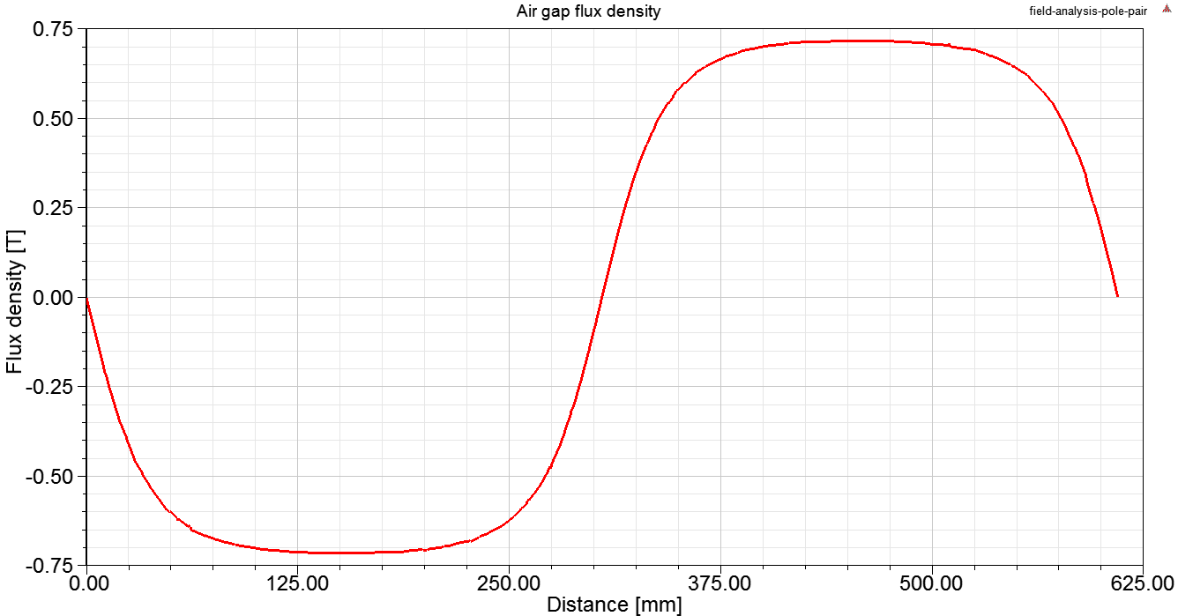

Figure 6: Air gap flux density over one pole-pair

When the FFT analysis is conducted on the air gap flux density distribution in Figure 6, it is observed the average value of the fundamental component, that is magnetic loading, is 0.539 T. Analytically, we found that magnetic loading is 0.556 T. Therefore, there is around 3% difference, which is mainly caused by the assumption that there is no leakage and fringing effect and there is no saturation in the cores. In overall, the obtained results are in good agreement with analytical calculations.

# Part IV: Comparison and Discussion

## Slot ratio optimization

# Başvurular

|  |  |
| --- | --- |
| [1] | A. L. F. P. S. B. A. B. M. D. M. M. Tessarolo, «Design for manufacturability of an off-shore direct-drive wind generator: An insight into additional loss prediction and mitigation,» *IEEE Transactions on Industry Applications,* cilt 3, no. 52, pp. 4831-4842, 2017. |
| [2] | E. S. R. N. T. I. A. S. M. Taherian-Fard, «Wind turbine drivetrain technologies,» *IEEE Transactions on Industry Applications,* cilt 2, no. 56, pp. 1729-1743, 2020. |
| [3] | T. K. J. C. R. W. F. G. L. de Paula Machado Bazzo, «Multiphysics design optimization of a permanent magnet synchronous generator,» *IEEE Transactions on Industrial Electronics,* cilt 12, no. 64, pp. 9815-9823, 2017. |
| [4] | H. F. J. J. B. A. A. A. K. Polinder, «Trends in wind turbine generator systems,» *IEEE Journal of Emerging and Selected Topics in Power Electronics,* cilt 1, no. 3, pp. 174-185, 2013. |
| [5] | B. Chalmers ve E. Spooner, «An axial-flux permanent-magnet generator for a gearless wind energy system,» *IEEE Transactions on Energy Conversion,* cilt 2, no. 14, pp. 14-19, 1999. |
| [6] | A. Daghigh, H. Javadi ve H. Torkaman, «Design Optimization of Direct-Coupled Ironless Axial Flux Permanent Magnet Synchronous Wind Generator With Low Cost and High Annual Energy Yield,» *IEEE Transactions on Magnetics,* cilt 9, no. 1, p. 52, 2016. |
| [7] | O. Keysan ve M. A. Mueller, «A Homopolar HTSG Topology for Large Direct-Drive Wind Turbines,» *IEEE Transactions on Applied Superconductivity ,* cilt 12, no. 5, pp. 3523-3531, 2011. |